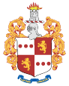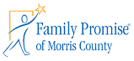

***Apply for:***

**SNAP   
(Supplemental Nutrition Assistance Program)**

**Medicaid**

**General Assistance (Cash)**

**TANF**

**(Temporary Assistance for Needy Families)**

**Utility Assistance**

**Housing Assistance**

**https://hs.morriscountynj.gov/navigating-hope/**

**navigatinghope@co.morris.nj.us**

**973-829-8220**

***Navigating Hope is sponsored by the Morris County Board of Chosen Freeholders***